
SC1007 Data Structures and Algorithms
Tutorial 4: Analysis of Algorithm

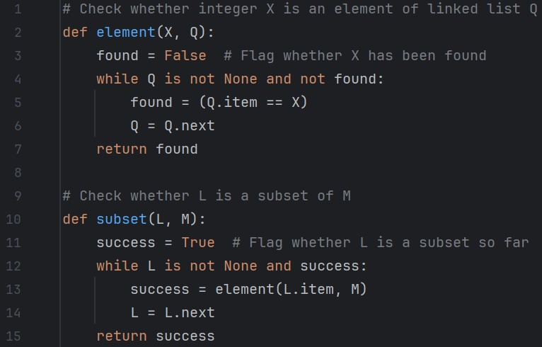
Q1 The function subset() below takes two linked lists of integers and determines whether the first is a subset of the second. Assume there are no duplicate numbers in each list.

- When will the worst case happen?
A is a subset, but each element is found only at the end of B
To obtain worst case, 2 conditions need to be met:
- The while loop in subset needs to take as many iterations as possible
- The while loop in element also needs to take as many iterations as possible

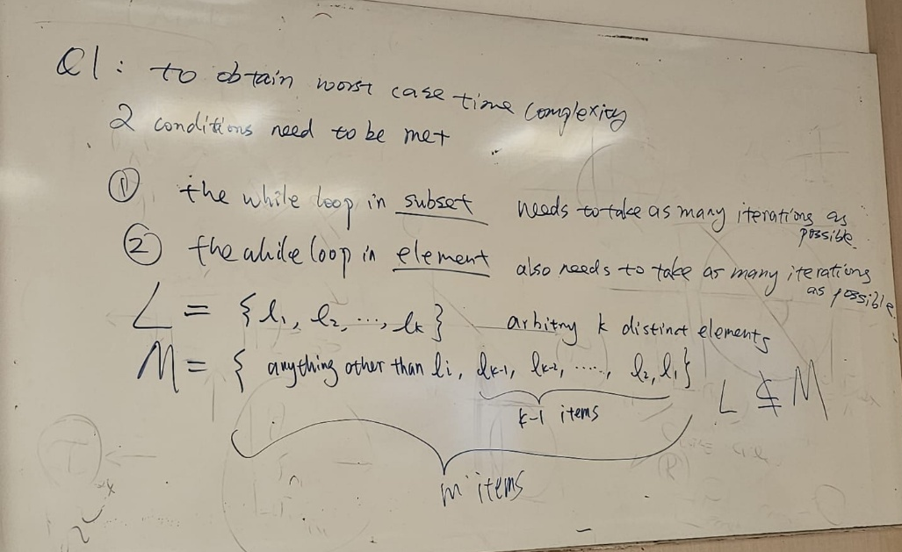
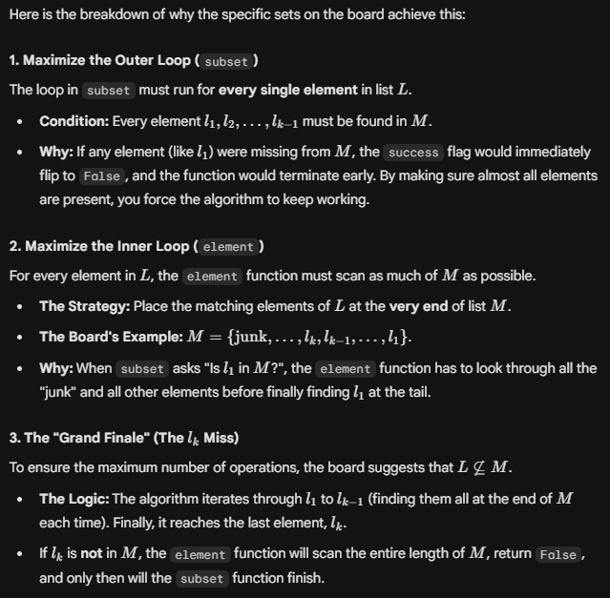

- In the worst case, how many item comparison operations will be made?
mk – [(k-2)(k-1)]/2

- Give the worst-case time complexity of subset as a function of the lengths of the two lists.
mk – [(k-2)(k-1)]/2

- Write down the worst-case time complexity in asymptotic notations in terms of the lengths of the two lists.
θ(mk)

Q2 Find the number of print called in the following functions. Write down its time complexity in Θ notation in terms of N.
Hint: For repetition structure, compute the number of inner loops and outer loops. For recursive structure, write down the number of print W(N) in terms of W(N-1). Then use backward substitutions or forward substitutions to express W(N) in terms of N. You may refer to the series shown in lecture.

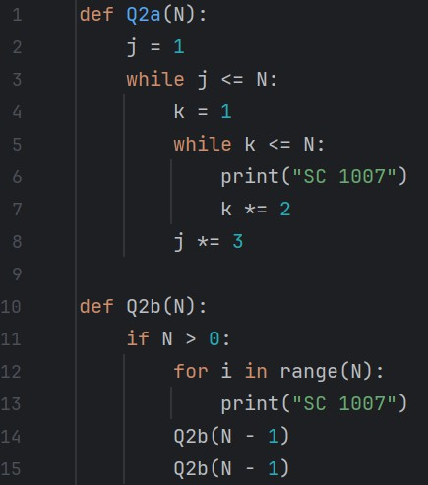

print=(a+1)(b+1) because exponent starts from 0
floor log3n + 1 * floor log2n + 1 not desirable form because you shouldn’t use constants at all
simplify expression to remove constants, can be written as O log2n^2
4-2

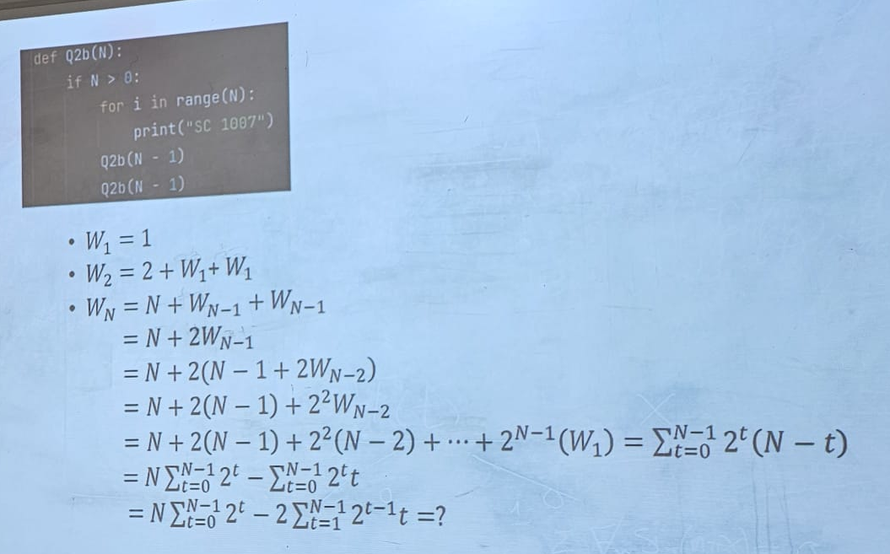
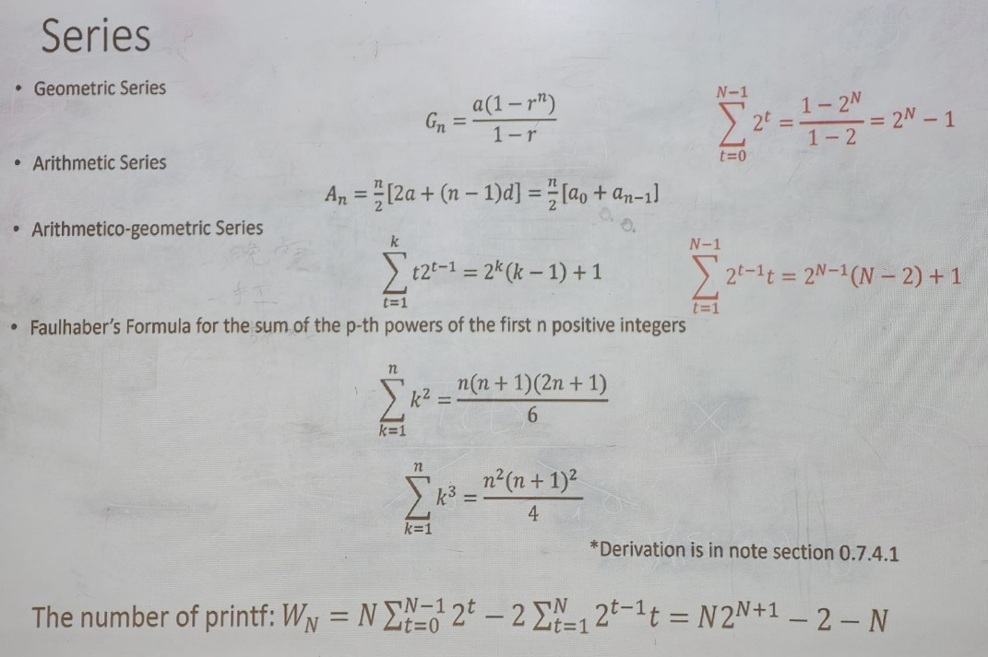

Q3 A sequence, x1, x2, . . ., xn, is said to be cyclically sorted if the smallest number in the sequence is xi for some i, and the sequence, xi, xi+1, ..., xn, x1, x2, ..., xi−1 is sorted in increasing order. Design an algorithm to find the minimal element in the sequence in O(log n) time. What is the worst-case scenario?

